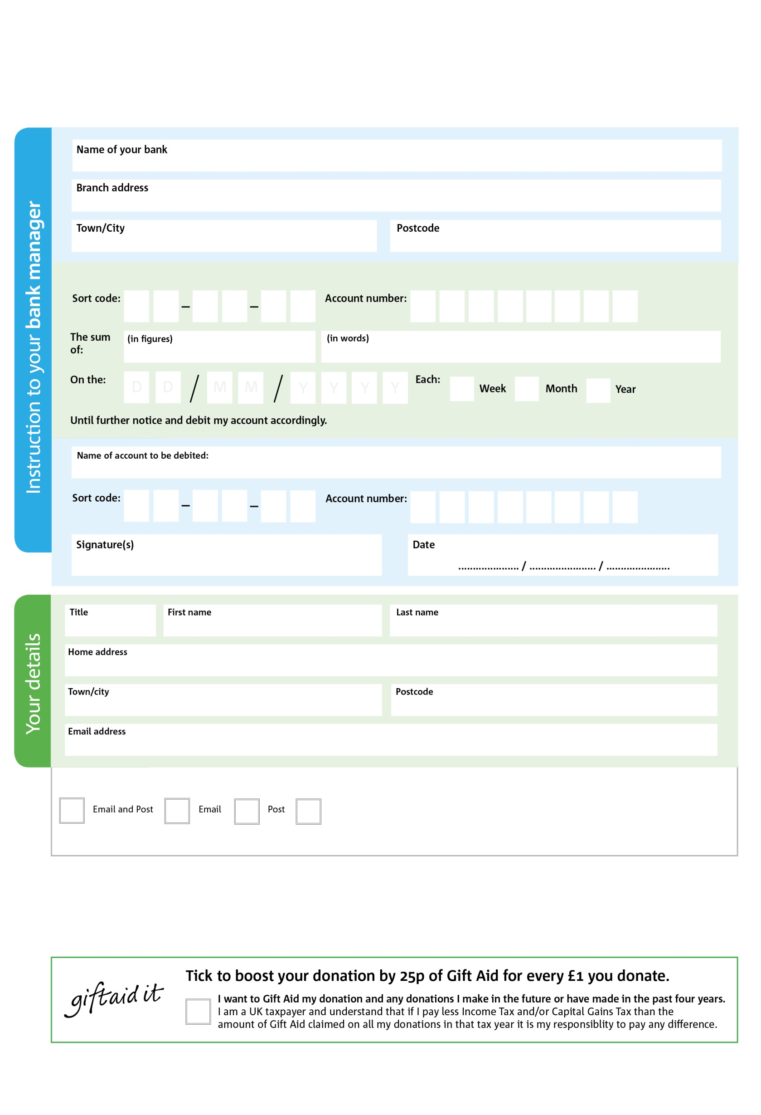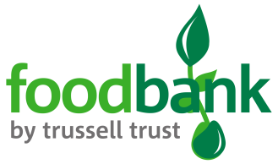

POSTAL ADDRESS: Normanton Foodbank, The Well Project, Haw Hill Park, off Castleford Road, Normanton, WF6 2DP

Reg. Charity No: 1143947 | Reg. in England & Wales

8X

V

7X

V

2X

V

0X

V

7X

V

7X

V

2X

V

3

V

**Please pass this form onto the foodbank, using the foodbank’s address at the bottom, who will save a copy for their records.   
They will then send it onto your named bank or building society.**

6

2

6

0

5

00

We would love to keep you up to date with information about Normanton Foodbank. Please tick your preference:

You can change your preferences any time by contacting us on 01924 895634 / 07872 551640 or emailing us at info@normanton.foodbank.org.uk

I do not wish to receive future communications from Normanton Foodbank

Please pay Normanton Foodbank,

**Data protection**

*'Normanton Foodbank is committed to protecting your privacy and will process your personal data in accordance with current Data Protection legislation. Normanton Foodbank collects information to keep in touch with you and supply you with information relating to our work. To unsubscribe from our newsletter, send a message to the email address above with the word unsubscribe in the subject line. A full data privacy statement for financial donors is available from the foodbank on request.’*

**Standing Order Mandate**

**Normanton.foodbank.org.uk**

You can change your preferences any time by contacting us on XXXXXXXXXXX or emailing us at XXXX@XXXXXXXXXX.foodbank.org.uk

I do not wish to receive future communications from XXXXXX Foodbank